User Manual

FMS^{NG} Application

Shell Energy Marketing and Trading India Private Limited
Project Sponsoring Business

Purchase Module

07 MAR 2024
Date

Table of Contents
1. Purchase Module Overview 3
1.1. User Interface / Screen Designs 3
2. Menu Network / Screen Navigation 4
2.1. Sub Module – Contract 4
2.2. Sub Module – Request/Approval 8
2.3. Sub Module –Nomination 9
2.4. Sub Module – Allocation 14
2.5. Sub Module – Remittance 17
3. Report Design and Layout 32
3.1. Sub Module – Reports 32
4. Auditing 36

Purchase Module Overview
FMS^{NG} Application is an efficient ETRM System for Domestic Gas Trading, customized to meet business requirement of Shell Energy Marketing and Trading India Private Limited (SEMTIPL).
FMSNG Purchase Module will create and manage all Domestic Gas Purchase workflow of the trading system as listed below:

• Purchase Deal Creation (Bilateral and Gas Exchange Deals) & Management
• Daily Buyer and Seller Gas Nomination
• Daily Gas Allocation
• Party and System generated Remittance
• Interfacing with SAP P80 to flow Financial Information
• System will trigger event based emails as applicable
• Management Reports

User Interface / Screen Designs

FMS^{NG} offers Responsive UI to enable usability via any smart phone, tab and laptop of any screen size. The Menus of Purchase module are as below:

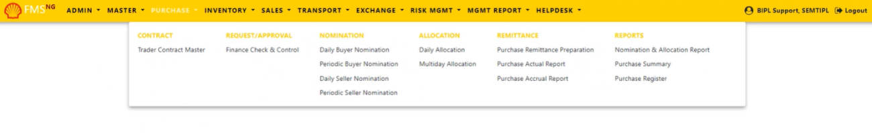

The responsive mode view over iPhone simulation:
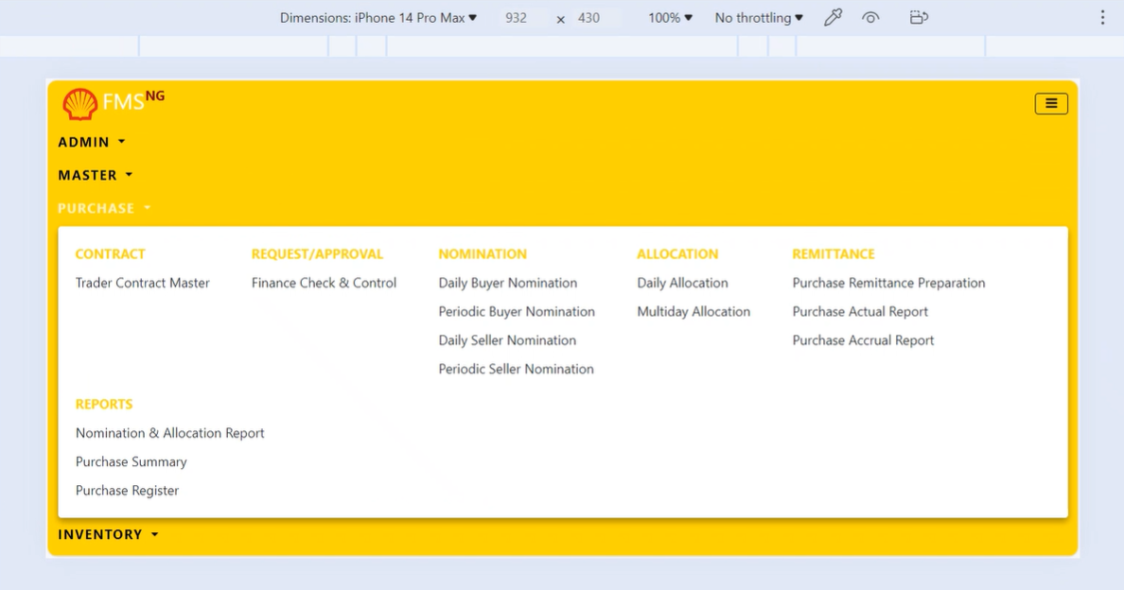

Menu Network / Screen Navigation
Menus in any Module are kept under different Groups for better categorization. The Groups under Purchase Module are Contract, Request/Approval, Nomination, Allocation, Remittance, Reports.

Sub Module – Contract

‘Contract’ Group contains FORM for Create and Modify Trader contracts.

Contract – Trader Contract Master

Trader Contracts in FMS^{NG} Application added/edited from this FORM by User who have access of Purchase Module.

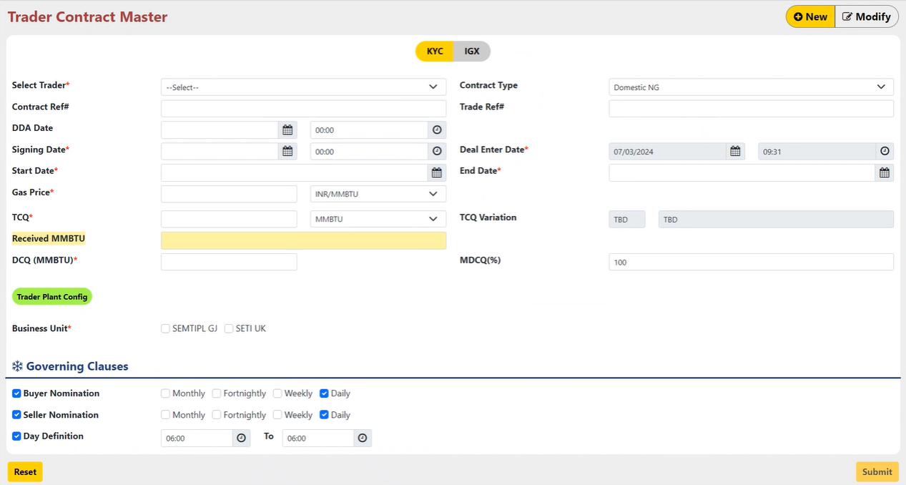

To add a new Contract, click on New at the right Top corner and enter required details or to Modify Contract, click on Modify at the right Top corner and change required details:
- Select Trader : Select Trader from Dropdown.
- Contract Type : Contract Type is Pre-Selected as “Domestic NG”.
- Contract Ref# : Enter Reference for Contract.
- Trade Ref# : Enter Reference for Trader.
- DDA Date : Select Deal Done Alert Date for the Contract.
- Signing Date : Enter the date and time, when deal was/will be signed.
- Deal Enter Date : Date and time are Pre-selected by the System as Deal Enter Date.
- Start Date : Enter Start date from when nomination and allocation will start.
- End Date : Enter End date, when nomination and allocation will end.
- Gas Price : Enter Gas Price and Currency for the Contract.
- TCQ : Enter Total Gas Quantity for the Contract.
- Received MMBTU : Received MMBTU will automatically filled according to the allocation (At the time of Modification Only).
- DCQ (MMBTU) : Enter Daily Gas Quantity for the Contract.
- MDCQ (%) : Maximum Daily Contractual Quantity can be more than 100% , can’t be less then 100%.
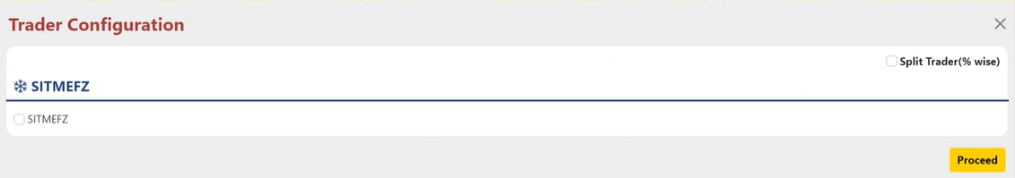
- Trader Plant Config : Configure Trader Plant by selecting checkbox & then Click on Proceed.
- Business Unit : Select Business Unit as per the Contract requirements.
- Governing Clauses : Select Duration for Buyer Nomination and Seller Nomination. And Define Timing for Day.

After inserting all the details, click on “Submit” Button. A dialogue box asking your permission to Create New Trader Contract appears as shown below:
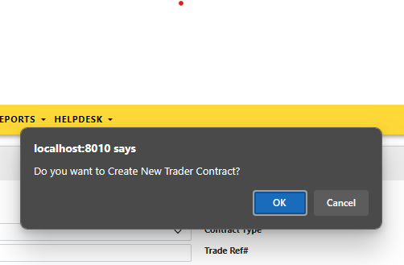
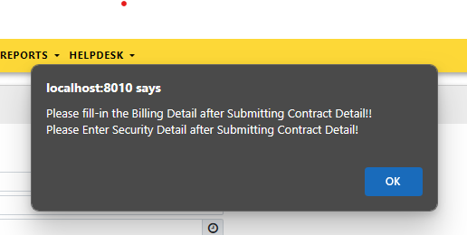
Click Ok on next dialogue box.

Press Ok. The status of Trader Contract Creation in system get displayed on the top of the screen.

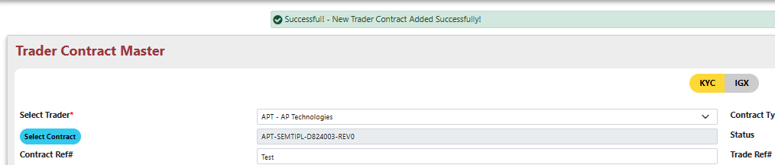

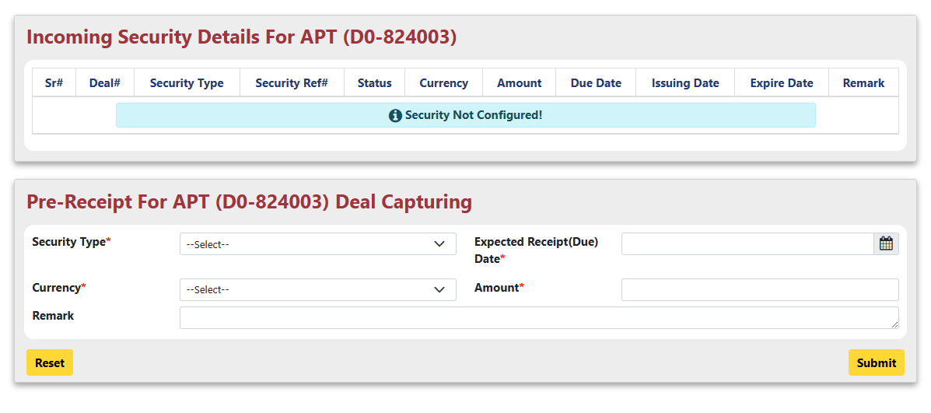
After that Select Security Config : Configure Security for the Contract.
- Security Type : Select Security type from Dropdown.
- Expected Receipt Date : Select Expected Receipt Date according to Contract.
- Currency : Select Currency from Dropdown.
- Amount : Enter Security Amount.
- Remark : Enter Remark for the Security.

Submit Security Configuration.

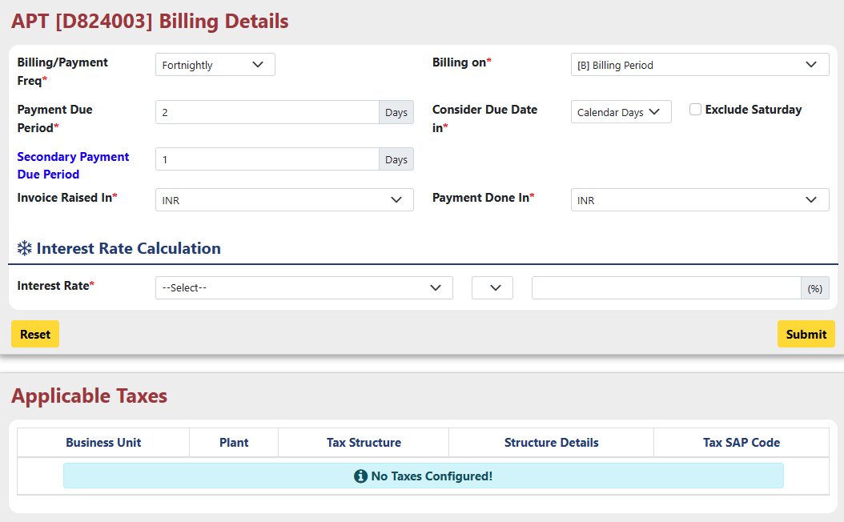
After that Select Configure Billing : Configure Billing Details for the Contract.

- Billing Freq : Select Billing Frequency from Dropdown.
- Billing on : Select On which Bases Billing Configured , On Billing Period Or On TCQ Completion.
- Payment Due Period : Enter Payment Due Period in days.
- Consider Due Date : Select whether Due Date in Calendar Days or Business Days.
- Second Payment Due Period : Select Second Payment Due Date in Days.
- Invoice Raised In : Select Currency In which Invoice will be Raised.
- Payment Done In : Select Currency In which Payment will be done.
- Interest Rate : Select interest rate From the dropdown and enter percentage of interest.

Submit Billing Details, Close the Billing Detail Page.
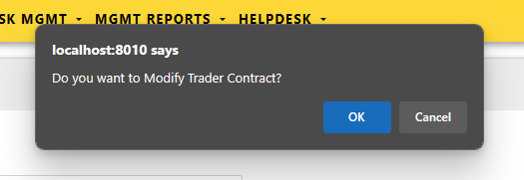
After that, click on “Submit” Button. A dialogue box asking your permission to Modify Trader Contract appears as shown below:

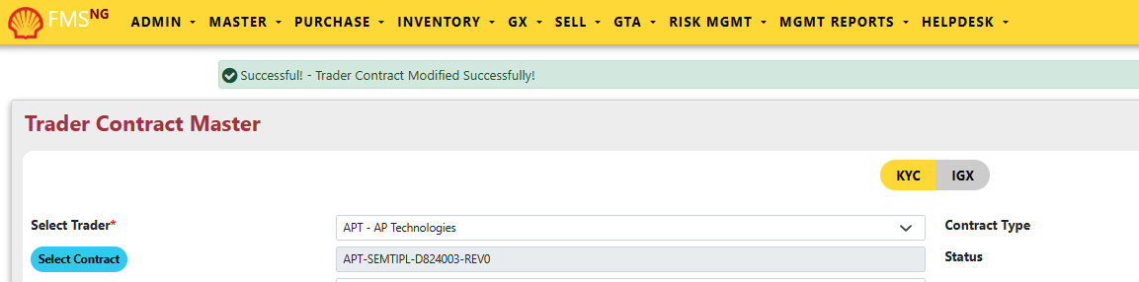
Press Ok. The status of Trader Contract Modification in system get displayed on the top of the screen.

Sub Module – Request/Approval

‘Request/Approval’ Group contains FORMs for Check and Approve Trader contracts.

Request/Approval – Finance Checks & Control

Only Users who have check and Approve access can allow to access this Form.

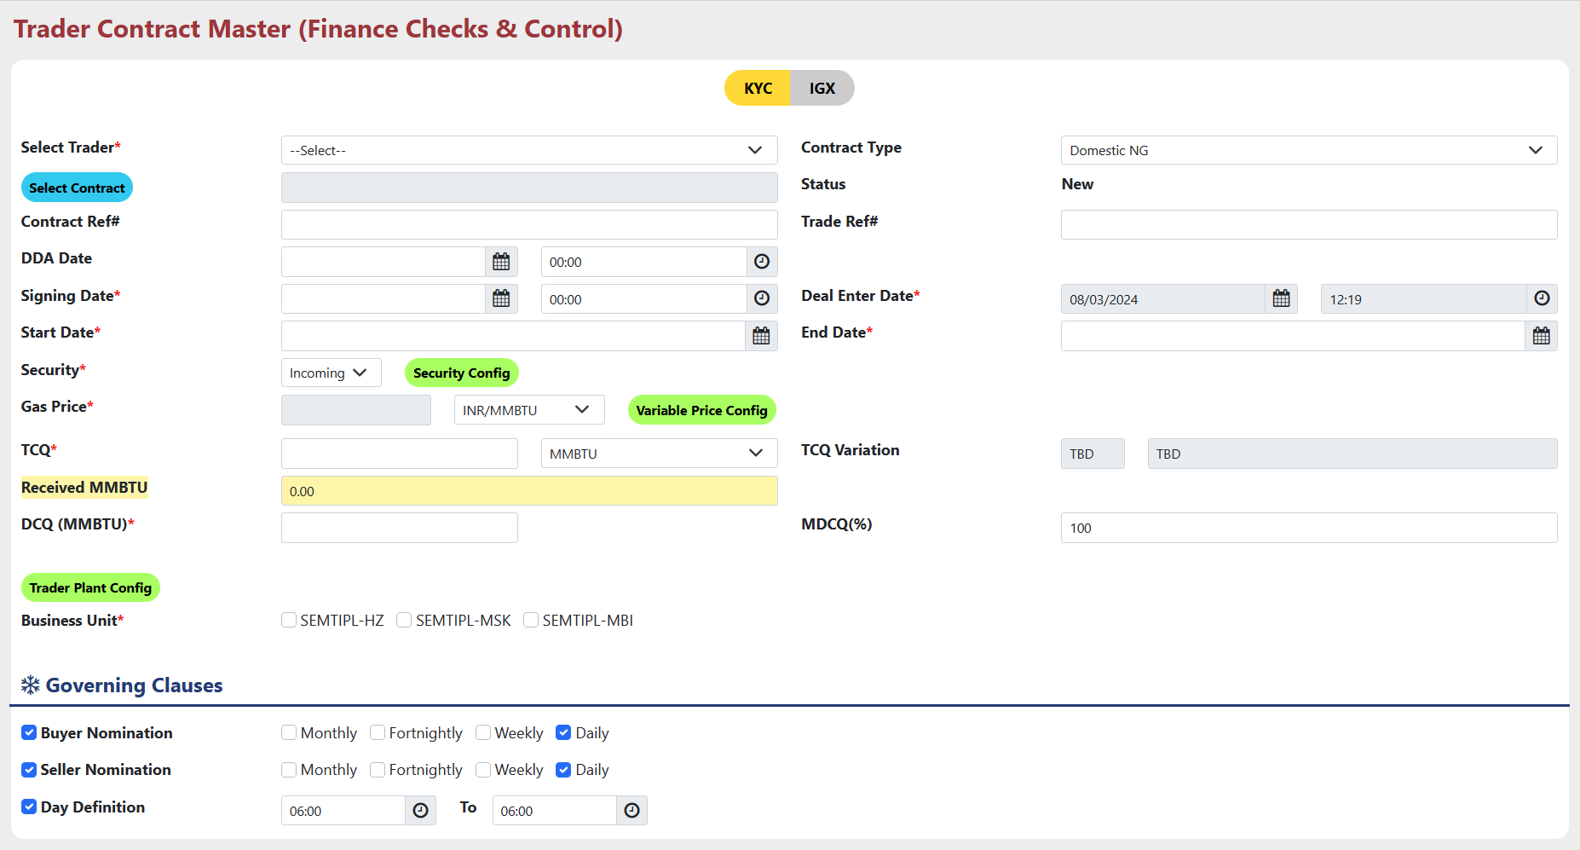

To Check Any Contract :
- Select Trader : Select trader from dropdown for which you want to check contract.
- Select Contract : Select Contract from the list for which you want to check and approve..
- Check all the Information filled on the page.
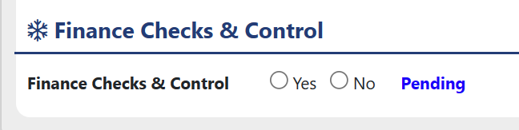
- Finance Check & Control : Select “Yes” to approve and “No” to Reject the Contract.

- Click “Ok” on Dialogue box for Approve or Reject Contract.
- Only Users who have access right can approve or reject the contract.

Sub Module –Nomination

‘Nomination’ Group contains FORMs for Nomination of Buyer and Trader for the Contractual Gas Quantity.

Nomination – Daily Buyer Nomination

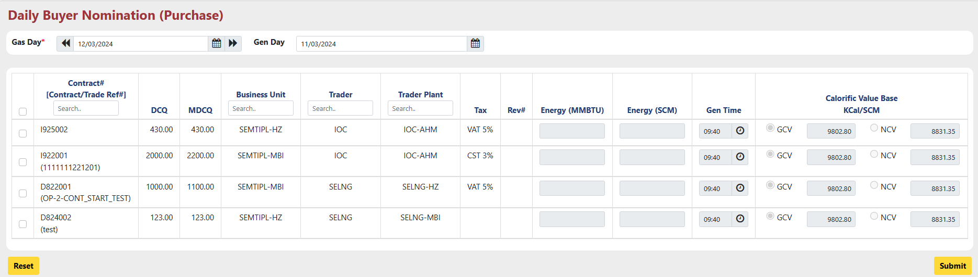
Daily Buyer Nomination for Purchase side is using for Buyer nomination for the Contractual Gas Quantity on a daily basis.

- Gas Day : Select Date for Which you want to Nominate gas quantity to Buyer.
- Gen Day : Gen Day is automatically selected as Previous day of Gas Day.
- Select checkboxes from the first column for which contracts you want nominate Gas quantity.
- Energy(MMBTU) : After selecting Checkbox , Energy(MMBTU) field will be enabled , Enter the value of Gas in MMBTU unit according to the DCQ and MDCQ.
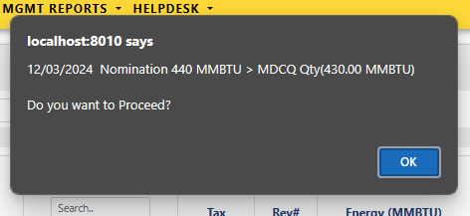
- If user Enters Value of Energy(MMBTU) grater than MDCQ , this alert message will be shown.
- User Can proceed by Pressing OK.
- Energy(SCM) : this field will be automatically filled as per the Energy(MMBTU) field.
- Gen Time : Gen Time is Pre-selected , It can be change by the user if Needed.
- Calorific Value Base : User can select between GCV and NCV as per the requirement.
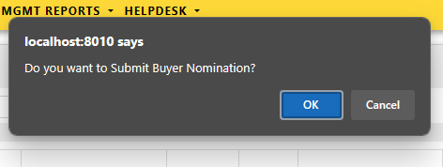
After that, click on “Submit” Button. A dialogue box asking your permission to Submit Buyer Nomination appears as shown below :

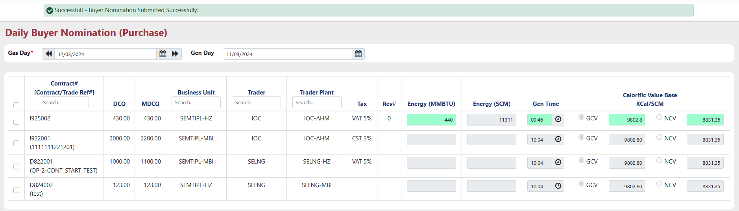
Press Ok. The status of Buyer Nomination submission in system get displayed on the top of the screen and the Energy(MMBTU), Gen Time & Calorific Value Base fields will be highlighted with green color :

Nomination – Periodic Buyer Nomination

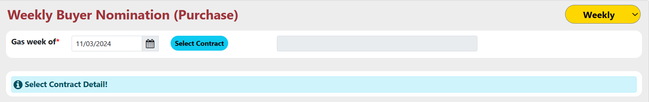
Periodic Buyer Nomination for Purchase side is using for Buyer nomination for the Contractual Gas Quantity on a Weekly, Monthly and Fortnightly basis as per the user requirement.

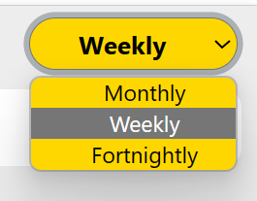
First, Select for which period nomination will be done from the Dropdown located at Top right corner.

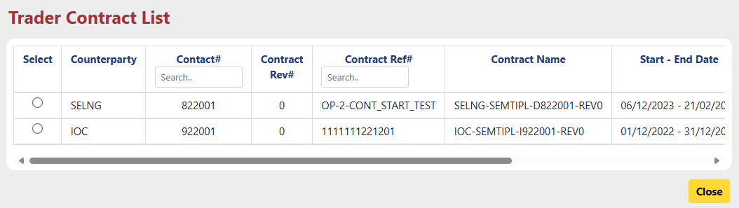
Select date on which date period Nomination will be done. Then Select Contract from the list by clicking on the “Select Contract” Button.

Select contract from the contract list by selecting radio button.

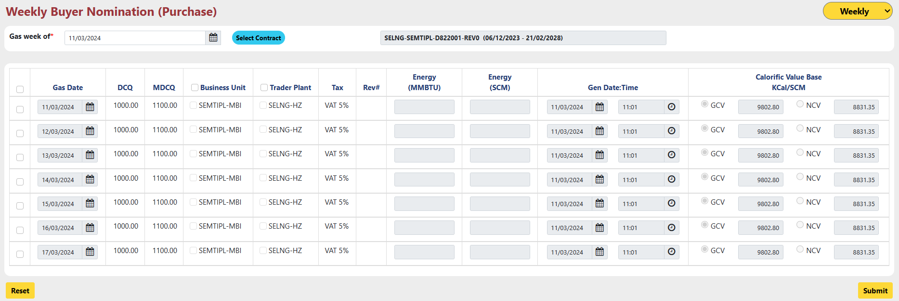
- Select checkbox for which date nomination will be done.
- Select Business unit and Trader plant for selected date.
- After that Enter Energy(MMBTU) and check Gen Date and Time.
- Select Calorific Value Base , GCV or NCV.

After that click on “Submit” button to submit the Buyer Nomination.
The process is same for Monthly and Fortnightly Buyer nomination.

Nomination – Daily Seller Nomination

Daily Seller Nomination for Purchase side is using for Seller nomination for the Contractual Gas Quantity on a daily basis.
This step comes after Daily Buyer Nomination was completed.
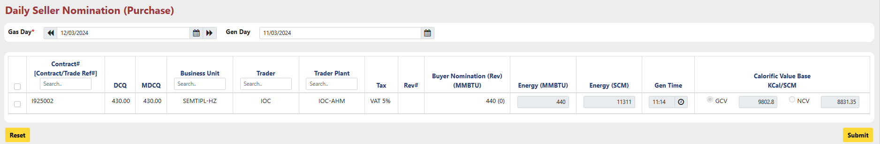
- Select Gas Day for which Daily Buyer Nomination is already completed.
- Select checkbox for which contract Seller Nomination will be done.
- After Selecting checkbox Energy(MMBTU) field will be enabled.
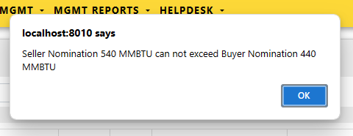
- User can change the value of Energy(MMBTU) , it can be less than or equals to Buyer Nomination(MMBTU) but it can’t be more than Buyer Nomination(MMBTU). If user insert more value than below alert will be shown.

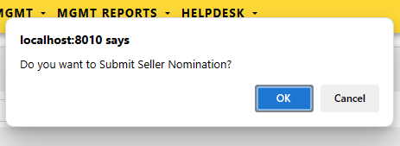
After that, click on “Submit” Button. A dialogue box asking your permission to Submit Daily Seller Nomination appears as shown below.

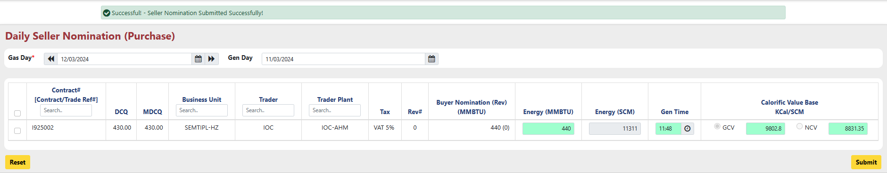
Press Ok. The status of Seller Nomination submission in system get displayed on the top of the screen and the Energy(MMBTU), Gen Time & Calorific Value Base fields will be highlighted with green color :

Nomination – Periodic Seller Nomination

Periodic Seller Nomination for Purchase side is using for Seller nomination for the Contractual Gas Quantity on a Weekly, Monthly and Fortnightly basis as per the user requirement.

This step comes after Periodic Buyer Nomination was completed

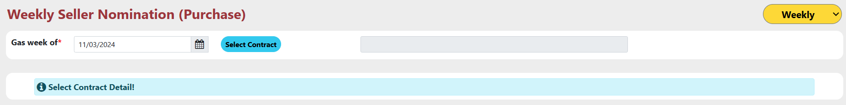

First, Select for which period nomination will be done from the Dropdown located at Top right corner.

Select date on which date period Nomination will be done. Then Select Contract from the list by clicking on the “Select Contract” Button.

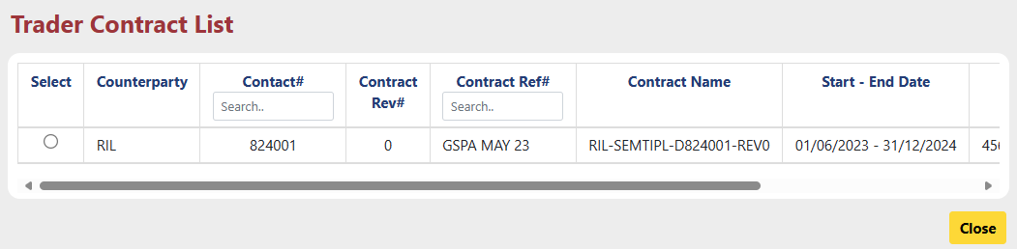
Select contract from the contract list by selecting radio button.

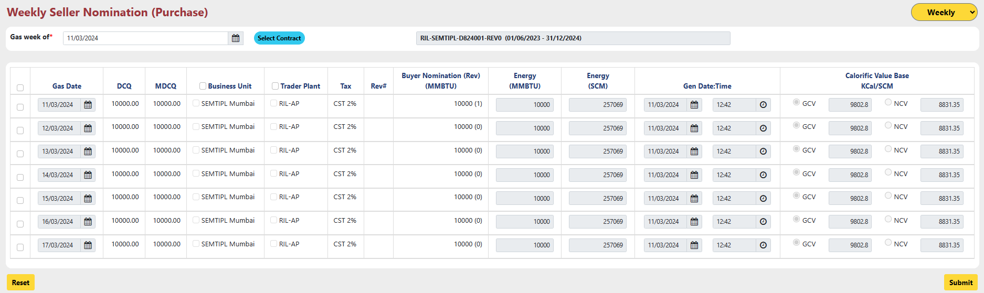
- Select checkbox for which date nomination will be done.
- Select Business unit and Trader plant for selected date.
- After that Enter Energy(MMBTU) and check Gen Date and Time.
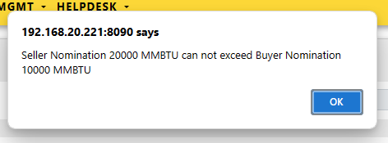
- User can change the value of Energy(MMBTU) , it can be less than or equals to Buyer Nomination(MMBTU) but it can’t be more than Buyer Nomination(MMBTU). If user insert more value than below alert will be shown.

- Select Calorific Value Base , GCV or NCV.

After that click on “Submit” button to submit the Seller Nomination.
The process is same for Monthly and Fortnightly Seller nomination.

Sub Module – Allocation

‘Allocation’ Group contains FORMs for Allocation of Contractual Gas Quantity on Daily and Multiday bases.

Allocation – Daily Allocation

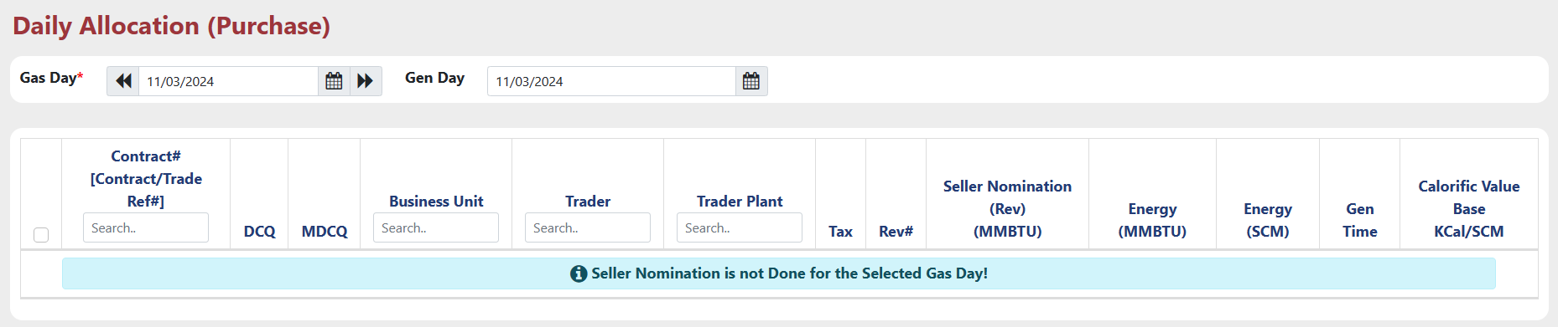
Daily Allocation for Purchase side is using for Allocation for the Contractual Gas Quantity on a daily basis.

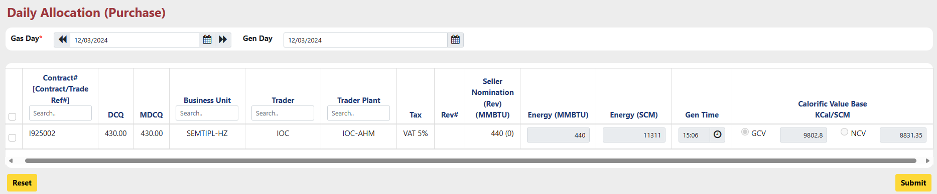
- Select Gas Day for which Seller Nomination already has been done.
- Select checkbox for which contract allocation will be done.
- User can change Energy(MMBTU) if needed.

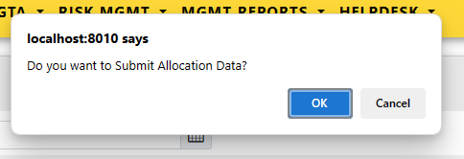
After that, click on “Submit” Button. A dialogue box asking your permission to Submit.

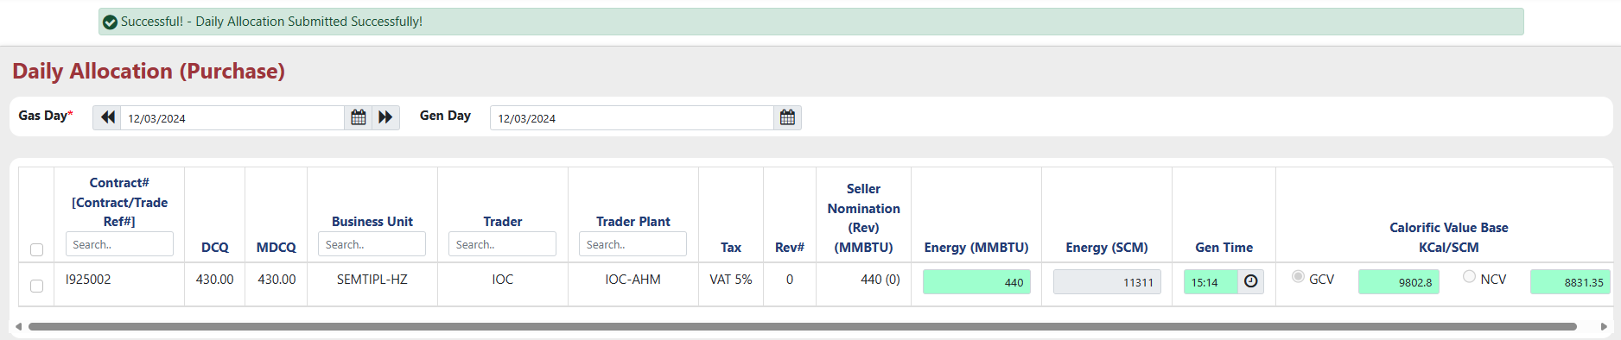
Press Ok. The status of Daily Allocation submission in system get displayed on the top of the screen and the Energy(MMBTU), Gen Time & Calorific Value Base fields will be highlighted with green color.

Allocation – Multiday Allocation

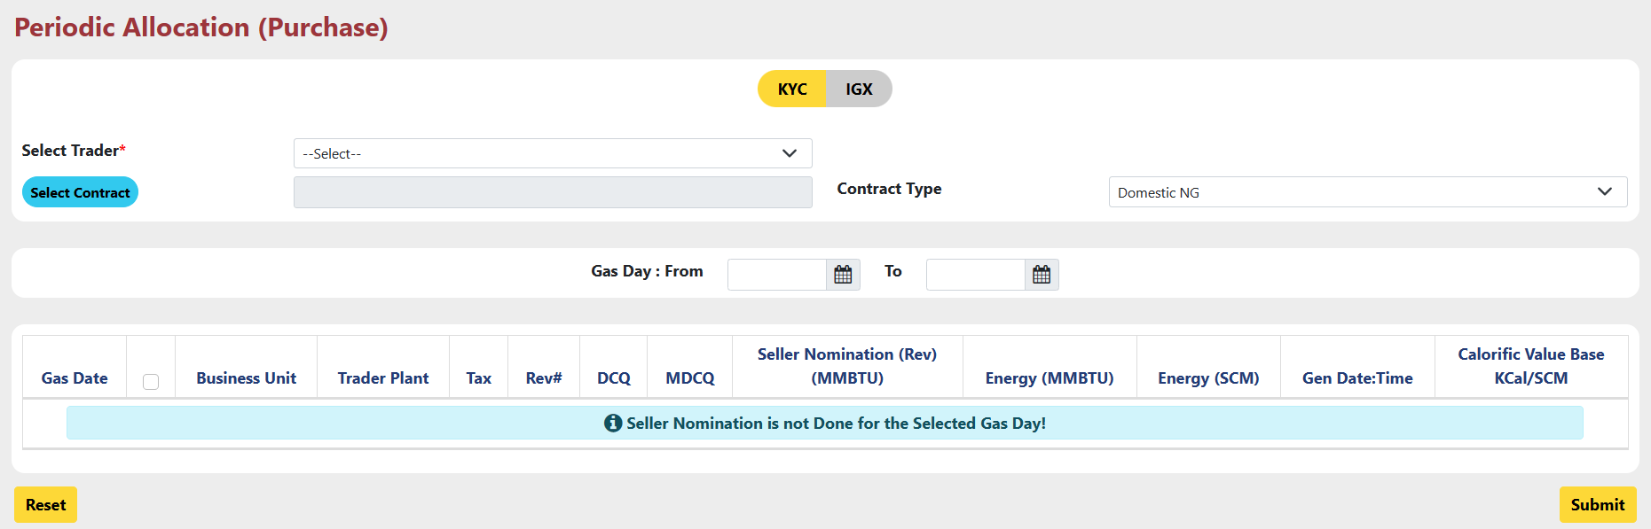
Multiday Allocation for Purchase side is using for Allocation for the Contractual Gas Quantity on a Multiday basis.

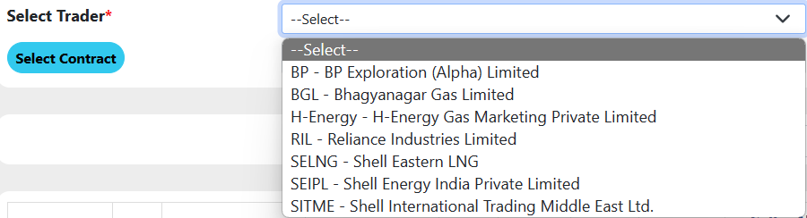
- Select Trader : Select trader from the dropdown.

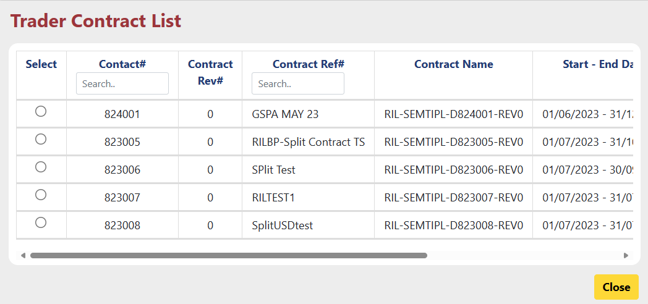
- Select Contract : Select Contract from the contract list by clicking on “Select Contract” button. Than select contract by selecting radio button.

- Contract Type : contract type is pre-selected as “Domestic NG”.
- Gas Day : “From” and “To” date are already been selected by the system as per the Contract period.
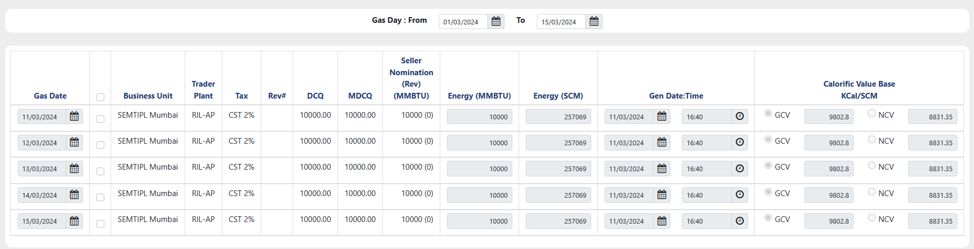
- Select checkbox for the Gas date for which allocation will be done.
- User can change Energy(MMBTU) if needed.

After that, click on “Submit” Button. A dialogue box asking your permission to Submit.

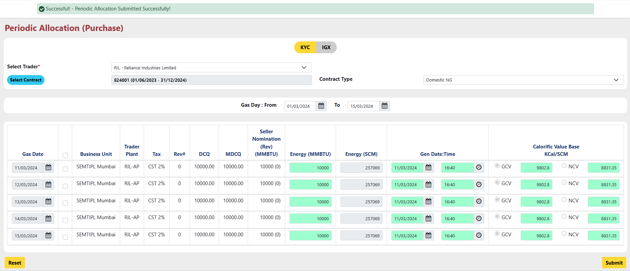
Press Ok. The status of Allocation submission in system get displayed on the top of the screen and the Energy(MMBTU), Gen Time & Calorific Value Base fields will be highlighted with green color.

Sub Module – Remittance

A remittance is amount that is sent from one party to another. Or we can say that any payment of an invoice or a bill can be called a remittance.

Remittance – Purchase Remittance Preparation

Purchase Remittance Preparation is used for generating remittance for purchase side. User can create Purchase free flow Remittance.
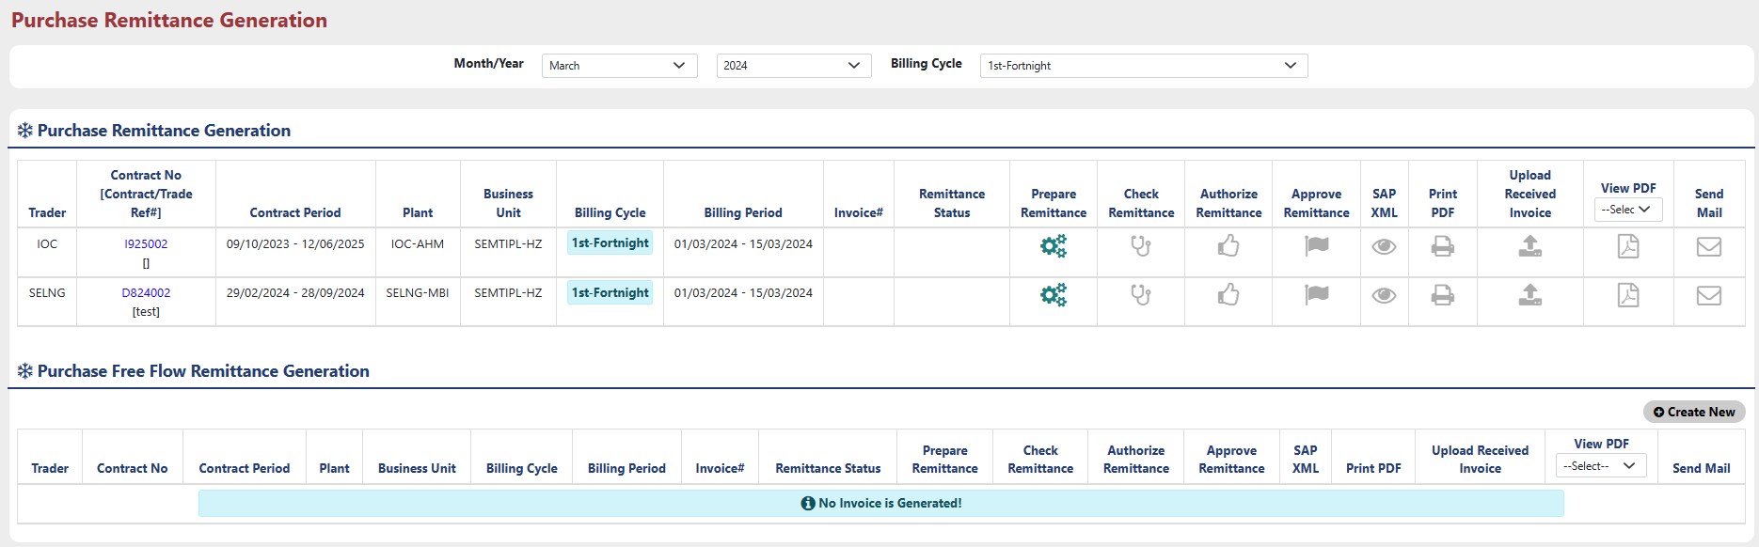
User can select “Month/Year” and “Billing Cycle” from the dropdown for which remittance will be generated.
Here User can generate remittance in two ways,
- First, go through all the nomination and allocation process as explained above after Creating Contract and then generate remittance.
- Second, Create Free flow remittance Using “Create New” button in this form without doing any Nomination and allocation process directly after creating Contract.

Method 1 : Follow below steps to Generate remittance through all the Process:

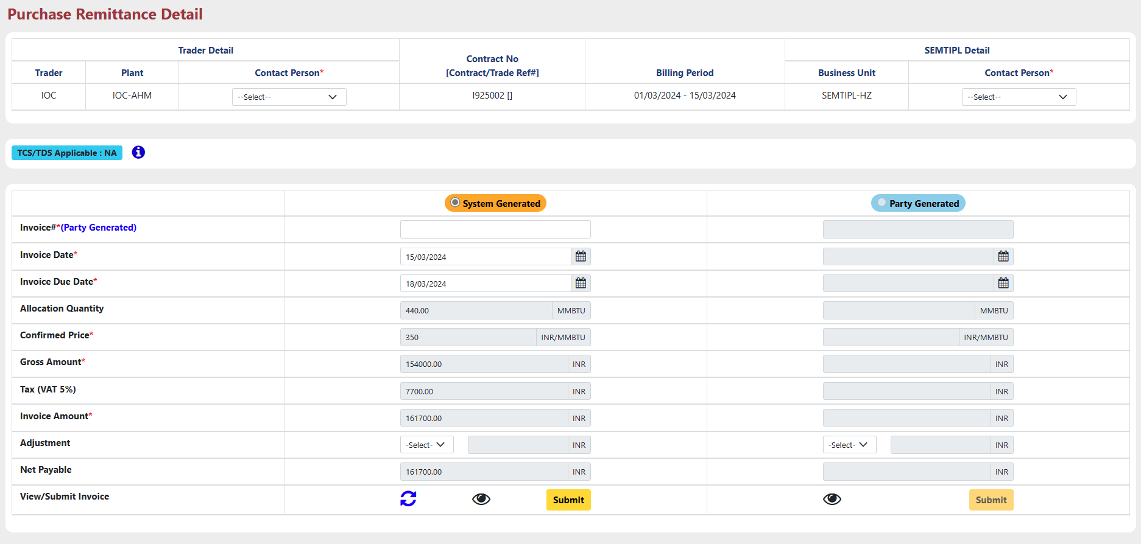
- Click on button to Prepare remittance for which user wants to generate remittance. The popup new screen will open shown as below.

- Select Contract Person from the drop down for both, Trader Details and Business details.
- Here, Two types of Invoice details can be entered, “System Generated” and “Party Generated”.
- In System Generated part all the details will be filled by the system by itself according to the contract details.
- In Party Generated part all the information will be entered by the trader.
Note*: Party Generated part will be enabled only after check remittance part will be completed for System generated Invoice.

- Fill all the required details.
- Use button to reset all the fields.

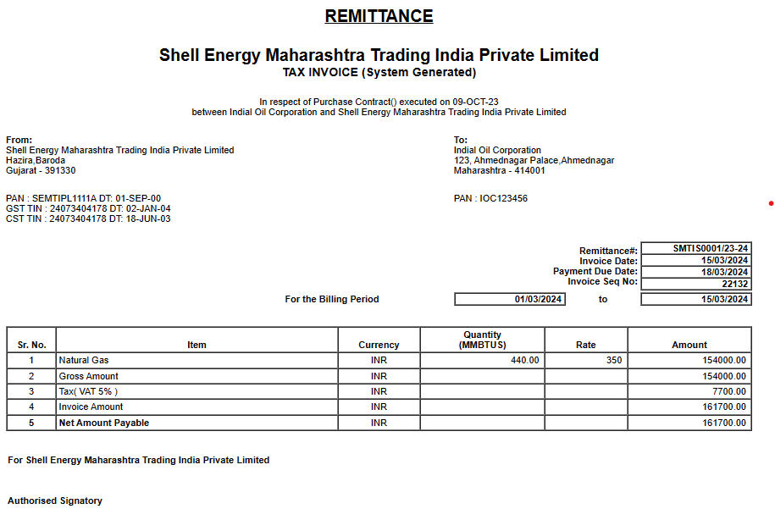
- Use button to view how the invoice will be look like.

- Click on “Submit” button to submit all the details and prepare remittance.

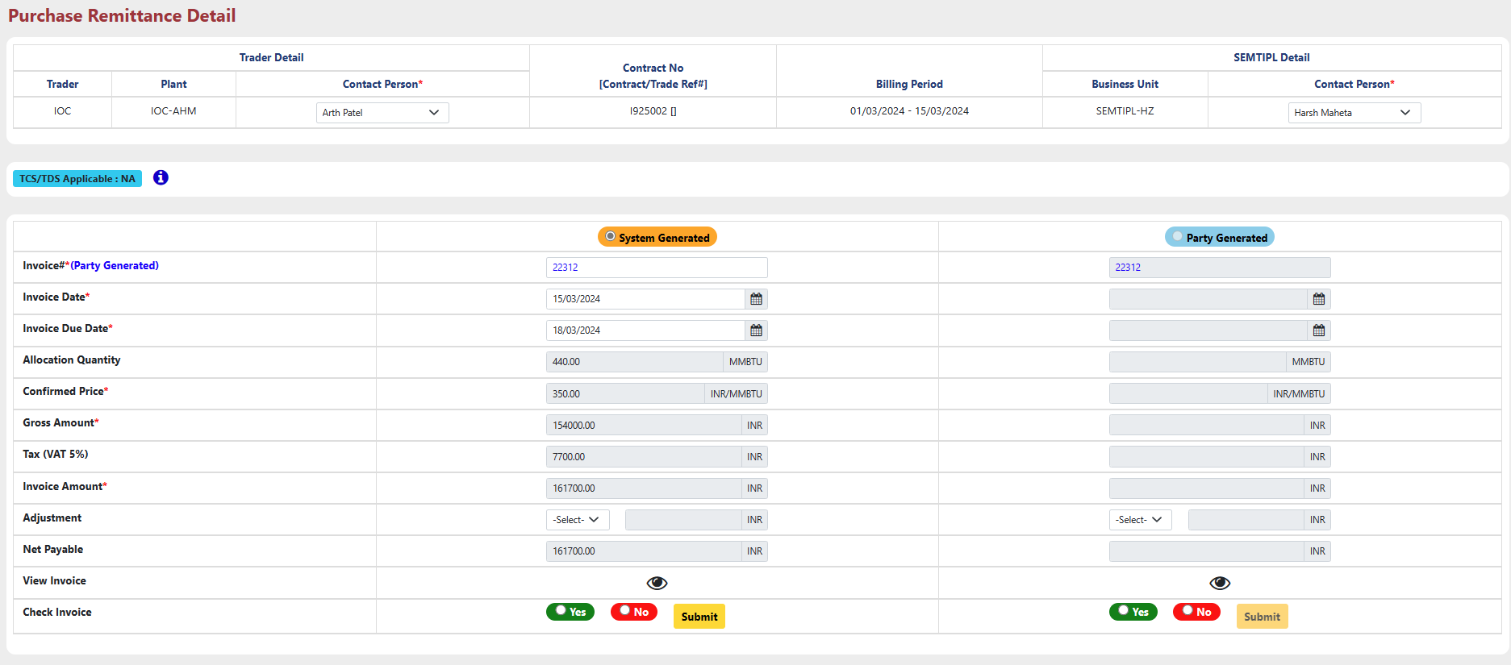


- After that button will be enabled. Use button to check whether all the details entered for remittance is correct or not.

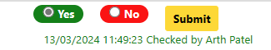
- Select “Yes” or “No” in order to check invoice and Click “Submit” button to submit response.
- After submission, this type of message will appear.
- After that button will be enabled. Use button to Authorize remittance details.
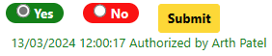
- To authorize Remittance details, Select “Yes” or “No” and then click “Submit” button.
- After submission, this type of message will appear.
- After that button will be enabled. Use button to Approve or Reject remittance details.
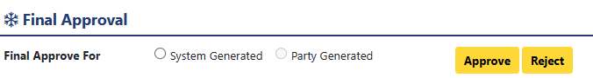

- Select “System Generated” or “Party Generated”, for which type invoice further process will execute. And then click “Approve” or “Reject” button.
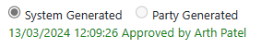

- After Approval, this type of message will appear.

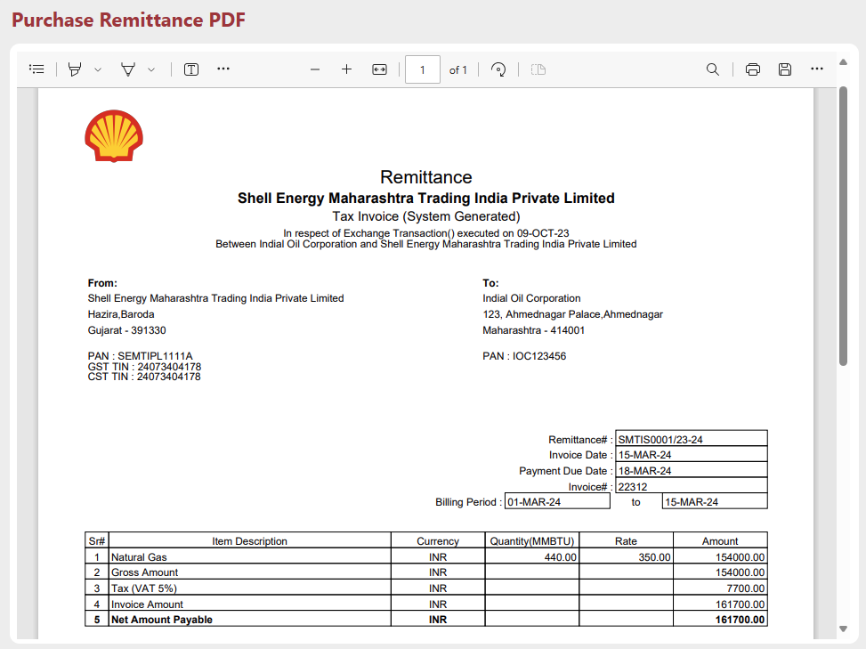

- After that, click on button in order to generate PDF.


- After generation of PDF, icon converted into icon. And all the other buttons will be disabled.
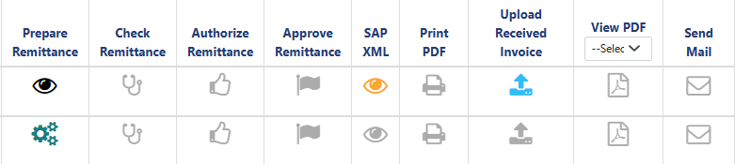

- After that, User Have to approve SAP-XML from the Purchase Actual Report.
- After approval of from the Purchase Actual Report, icon will be converted into .

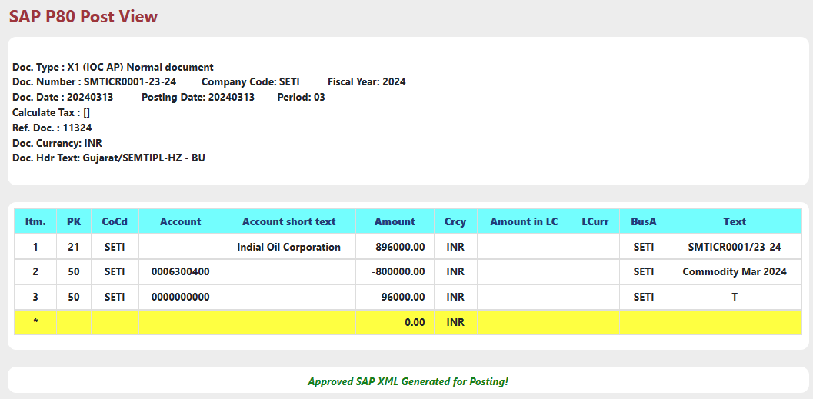

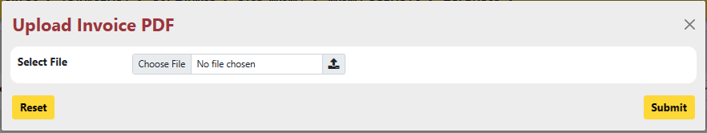

- User can Upload Received Invoice from the party i.e. Party Generated Invoice using button.

- Select PDF file from your system and click “Submit” button.

- After Submission icon will be converted to icon.

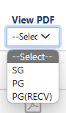
- User can view Invoice in pdf format by selecting type of Invoice from the dropdown.

- Here SG : System Generated
PG : Party Generated
PG(RECV) : Party Generated Received (Uploaded using button.)

- After Selecting any type, if PDF file is available then will be enabled and will be look like .
- User can view PDF using button.

- User can send mail directly from this form using button only after uploading received Invoice.
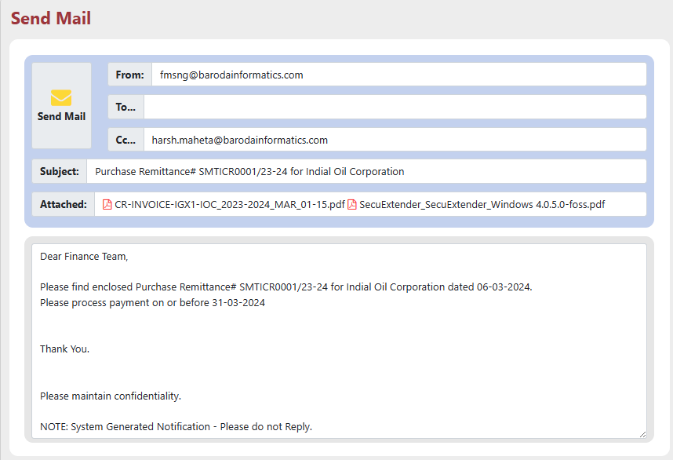
- Click on “Send Mail” Button to send mail.

Method 2 : Follow below steps to Generate Purchase Free Flow Remittance :

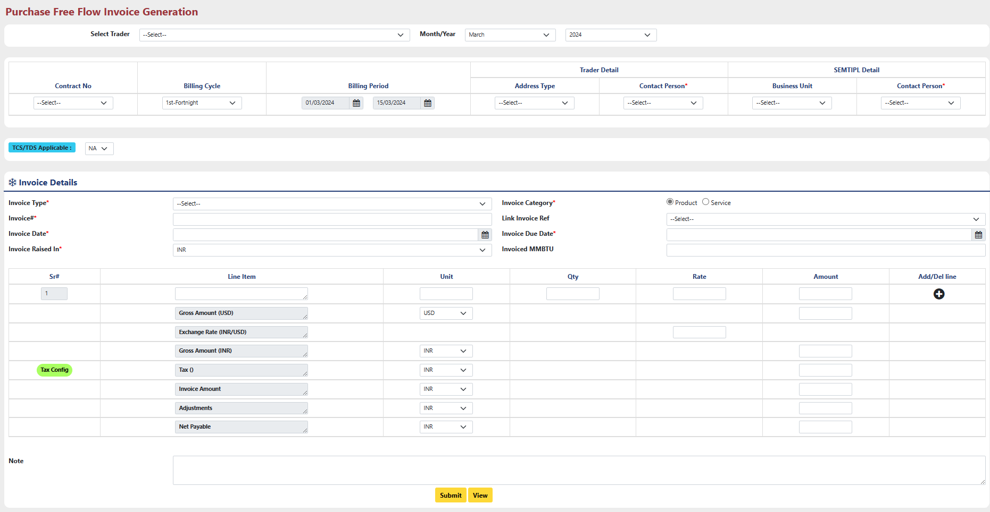
- Click On “Create New” button located at the top right corner of the ‘Purchase Free Flow Remittance Generation’ Part.

- Select Trader: Select trader from the dropdown for which Invoice will be generated.
- Month/Year: Select month & year from the dropdown.
- Contract No. : Select Contract for the selected Trader from the existing Contracts.
- Billing Cycle: Select billing cycle according to the requirement.
- Address Type (Trader Details): Select address type for which invoice will be generated.
- Contact Person (Trader Details): Select Contact person for the Selected Trader.
Note*: It is mandatory to select Address Type First and then only Contact Person can be selected.
- Business Unit (owner (SEMTIPL) Details): Select Business Unit from the dropdown.
- Contact Person (owner (SEMTIPL) Details): Select Contact person from the dropdown.
Note*: It is mandatory to select Business Unit First and then only Contact Person can be selected.
- TCS/TDS Applicable: If “TCS” or “TDS” applicable on the invoice, select from the dropdown, else Select “NA” to proceed further.
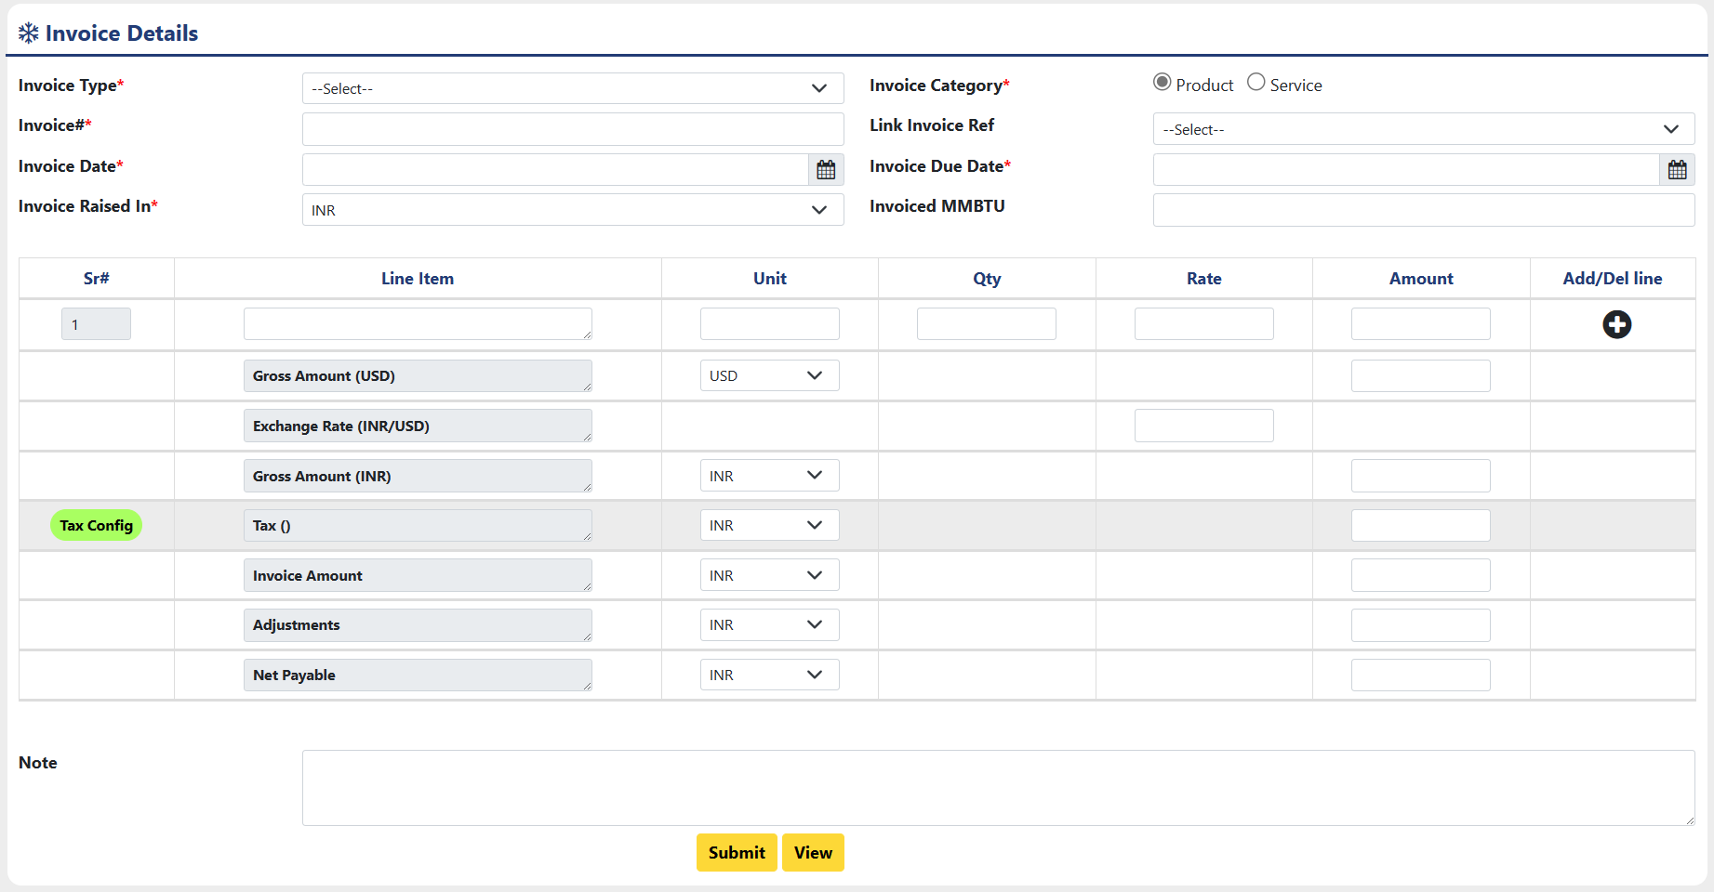
- Invoice type: Select Invoice Type from the Dropdown.
- Invoice Category: Select Invoice Category, for which category invoice will be generated.
- Invoice#: Enter invoice number.
- Link Invoice Ref: Link reference with invoice if any available.
- Invoice Date: Enter date on which invoice will be raised.
- Invoice Due Date: Enter due date for invoice.
- Invoice Raised In: Select In which Currency Type Invoice will be raised.
- Invoiced MMBTU: Enter quantity of Gas in MMBTU unit, for how much of quantity Invoice will be generated.
- Line Item: User have to enter Name of Item (Product or Service) for which Invoice will be generated at the first Row of Line Item Column.
- Unit: Enter Unit as “INR” or “USD” as per the item’s amount.
- Qty: Enter quantity of item.
- Rate: Enter Rate of the Item.
- Amount: Enter Price of Item.
- Add/Del Line: User can add more lines in order to add more item.
- Gross Amount (USD): Enter Gross Amount in USD in Amount Column.
- Exchange Rate: Enter your preferred exchange rate from USD to INR.
- Gross Amount (INR): Enter Gross Amount in INR according to exchange rate.
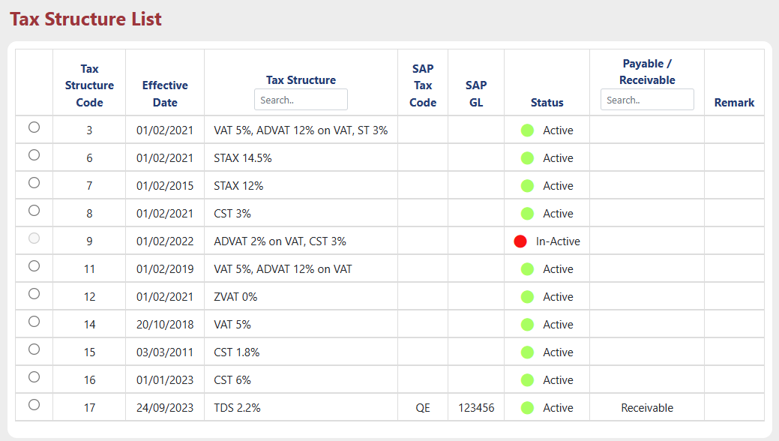
- Tax (): Configure tax details by using “Tax Config” button.
Select preferred tax from the list. Enter Tax amount in amount Column.
- Invoice Amount: Enter Total amount of Invoice in amount column.
- Adjustment: Enter amount of adjustment if applicable.
- Net Payable: Enter the final payable amount after Adjustment will be paid.
- Note: User can add some note for future reference.

Click “Submit” button to submit all the details.
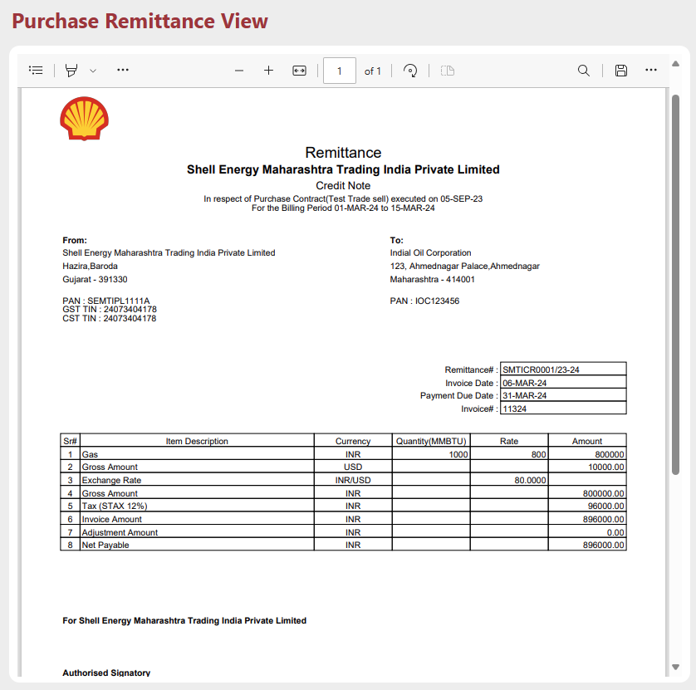
After Successful submission, User can see how invoice view will be like by using “View” button.


- After that, this free flow Invoice will be shown at ‘Purchase Free Flow Remittance Generation’ part.
- User can modify details of this free flow remittance using button.
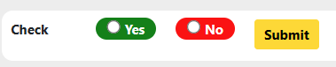

- After that, Use button to check whether all the details entered for remittance is correct or not.
- Select “Yes” or “No” in order to check invoice and Click “Submit” button to submit response.
- After submission, this type of message will appear.
- After that button will be enabled. Use button to Authorize remittance details.
- To authorize Remittance details, Select “Yes” or “No” and then click “Submit” button.
- After submission, this type of message will appear.
- After that button will be enabled. Use button to Approve remittance details.
- To approve Remittance details, Select “Yes” or “No” and then click “Submit” button.
- After Submission, this type of message will appear.

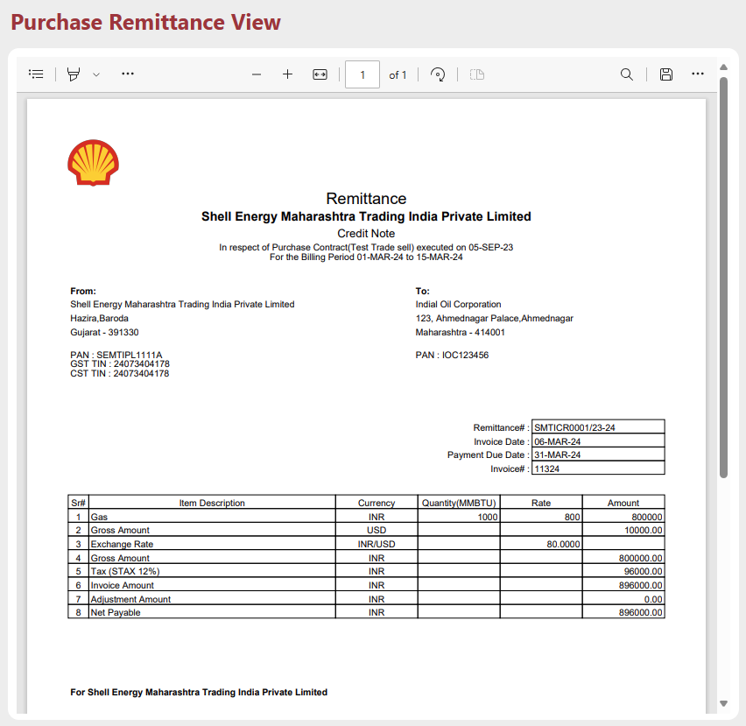
- After that, click on button in order to generate PDF.

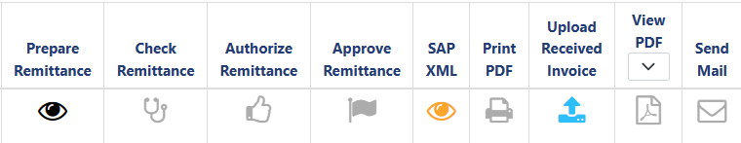


- After generation of PDF, icon converted into icon. And all the other buttons will be disabled.

- After that, User Have to approve SAP-XML from the Purchase Actual Report.
- After approval of from the Purchase Actual Report, icon will be converted into .




- User can Upload Received Invoice from the party i.e. Party Generated Invoice using button.

- Select PDF file from your system and click “Submit” button.
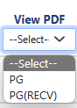

- After Submission icon will be converted to icon.

- User can view Invoice in pdf format by selecting type of Invoice from the dropdown.

- Here
PG : Party Generated
PG(RECV) : Party Generated Received (Uploaded using button.)

- After Selecting any type, if PDF file is available then will be enabled and will be look like .
- User can view PDF using button.

- User can send mail directly from this form using button only after uploading received Invoice.

- Click on “Send Mail” Button to send mail.

Remittance – Purchase Actual Report

Purchase Actual Report will be generated for the Contracts after remittance were generated.
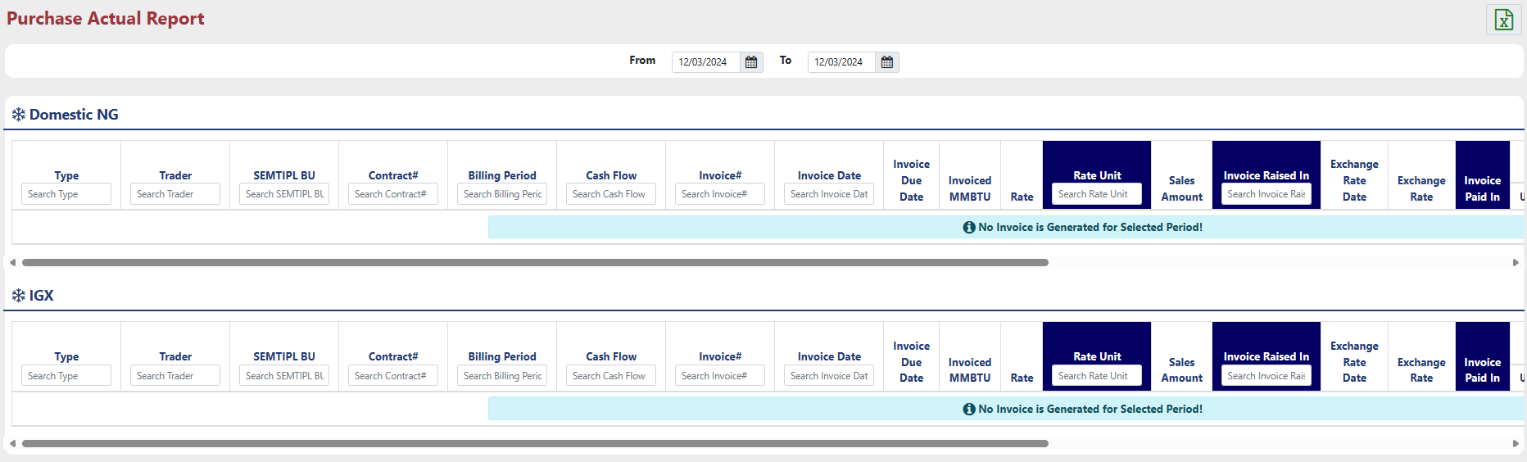
Increase Date Range by changing ‘From’ and ‘To’ date.
Purchase Actual Report contains all the information about Contract and Invoice Raised for available contracts.

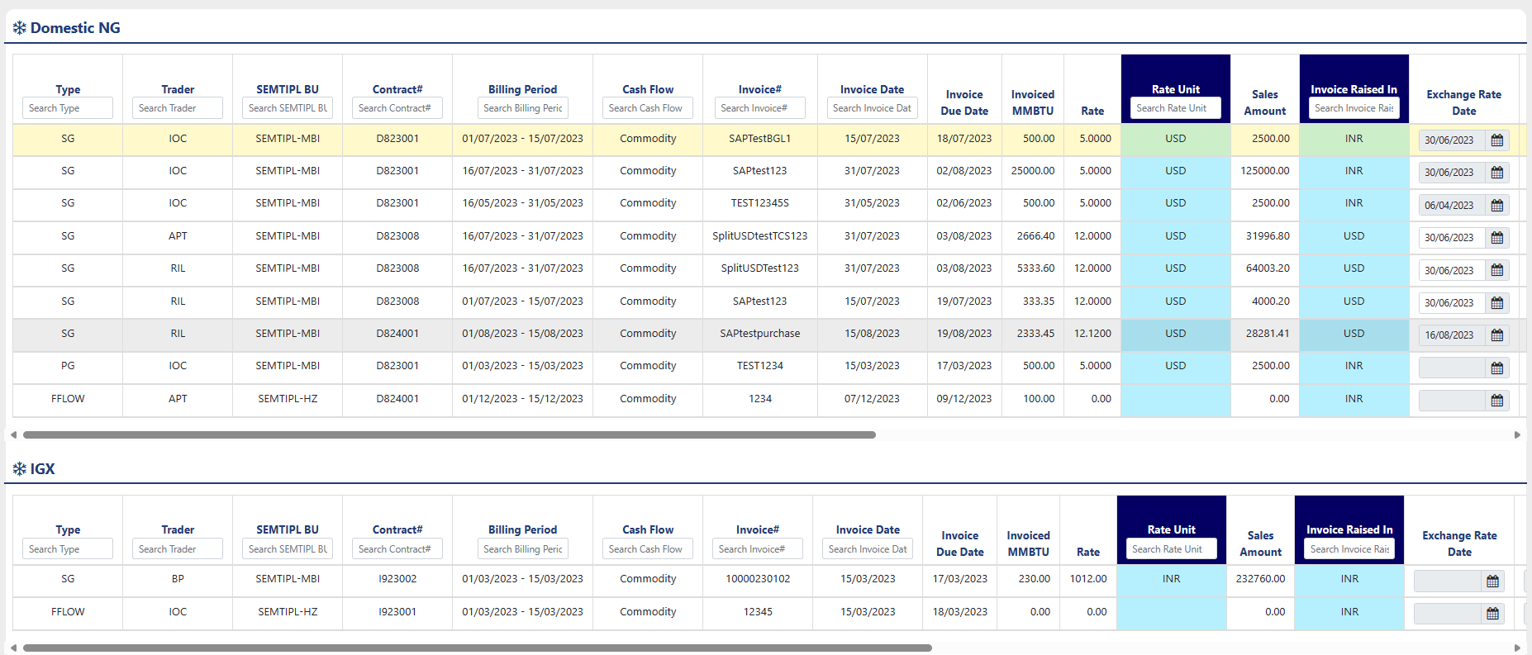
User have to generate and approve “SAP-XML” by using the icon at the end of every row for that corresponding contract.

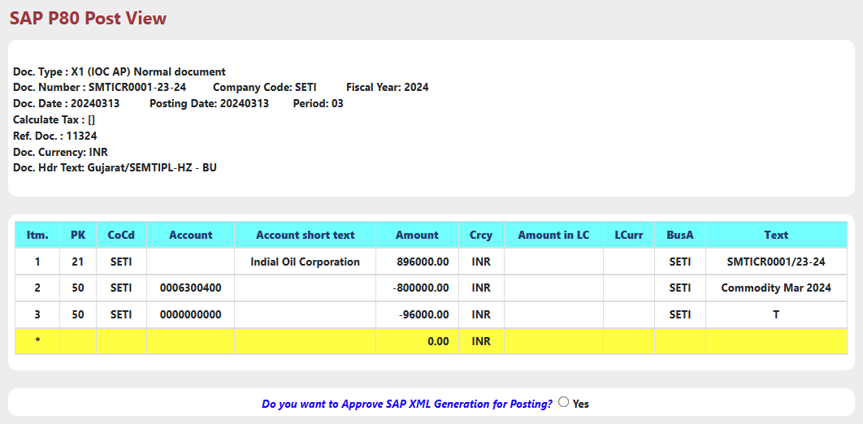
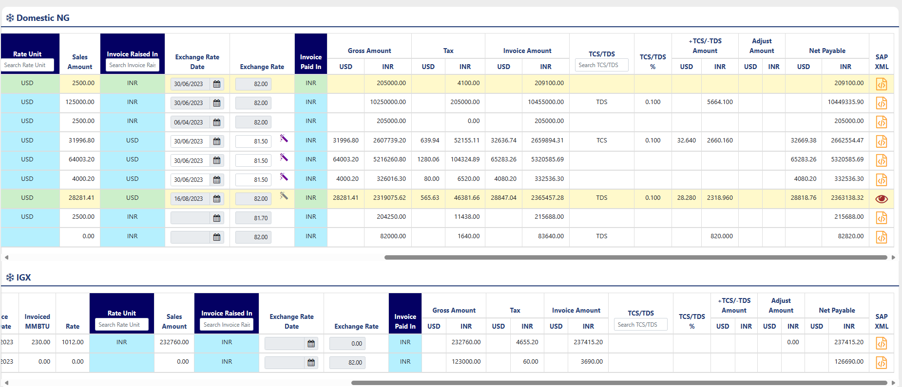

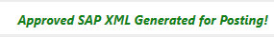
Click Yes, After Approval Status will be shown like below.

Remittance – Purchase Accrual Report

Purchase Accrual Report will generated before the Invoice were generated.
This Report contains all the Information about contract and accrual Gas amount.
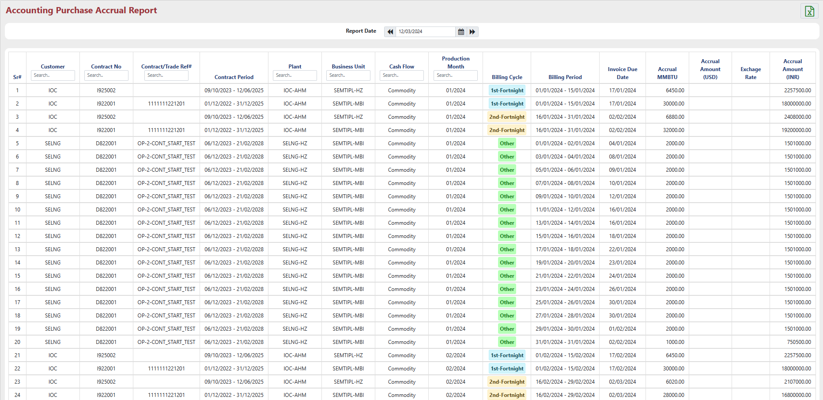

Report Design and Layout

Sub Module – Reports

‘Reports’ Group contains REPORTs for all the Purchase side Nomination and Allocation Details.

Reports – Nomination & Allocation Report

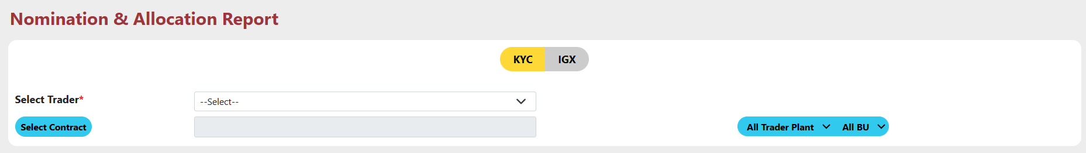
Nomination & Allocation Report contains all the information about Buyer Nomination , Seller Nomination and Allocation Date wise Details according to the Trader and Contract.

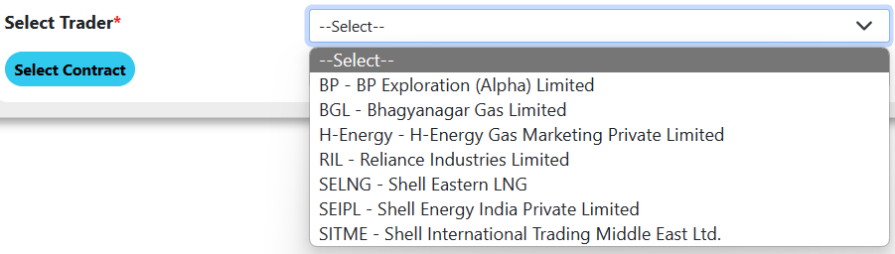
- Select Trader : Select Trader from the dropdown.


- Select contract : Select contract from the contract list for the selected trader by clicking on “Select Contract” button.

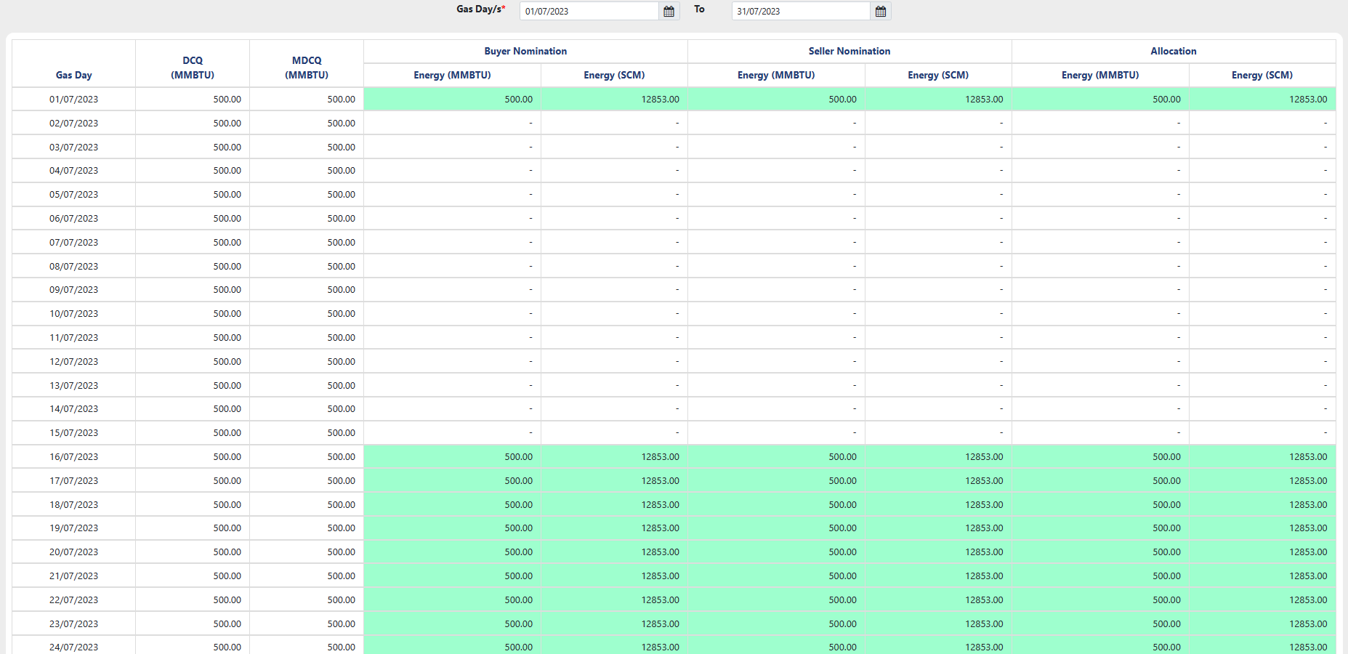
- After Selecting Contract, All the Nomination and Allocation Data will come.

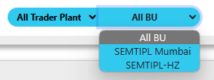
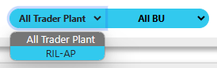
- User Can filter data according to the Available ‘Trader Plant’ and ‘Business Unit’ by Using the Drop down lays after “Select Contract” button.

Reports – Purchase Summary

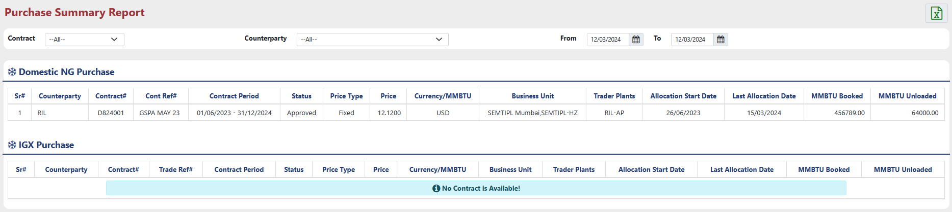
Purchase Summary Reports contains all the information about Purchase contract.

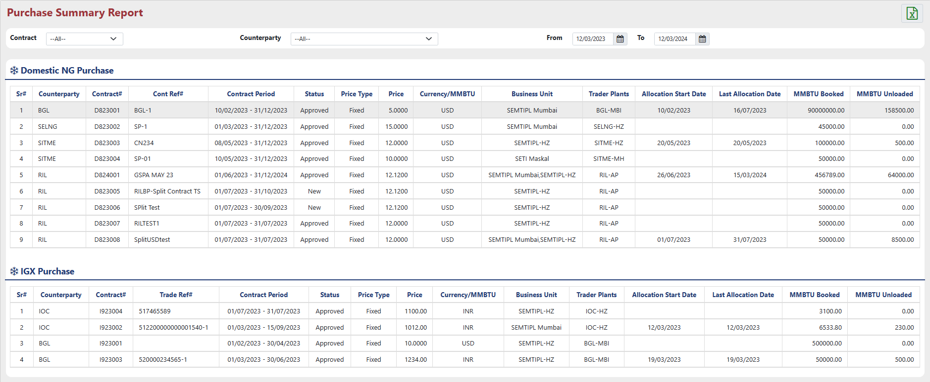
User can increase date range by changing ‘From’ and ‘To’ Date.

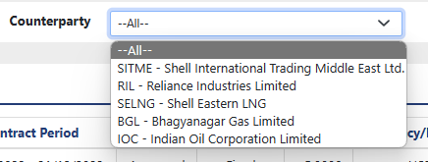
User can filter data according to the Contract type & Counterparty by selecting from Drop down located at Top left Corner.
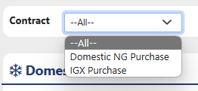

Reports – Purchase Register

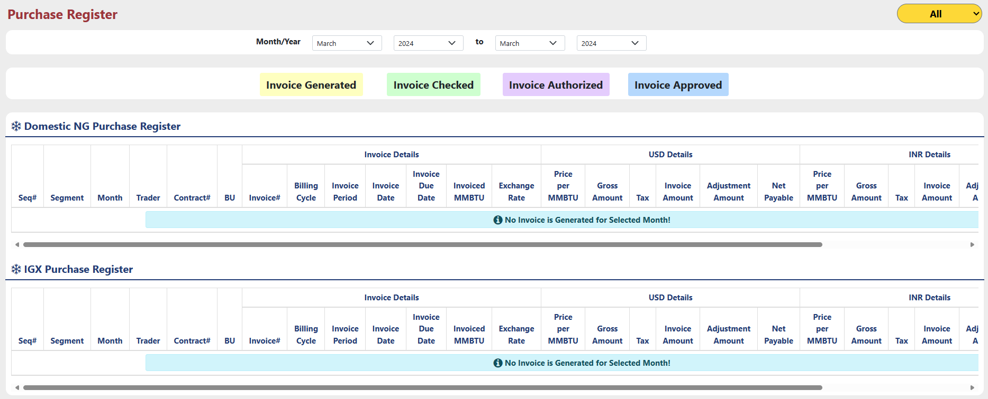
Purchase Register Contains all the Information about Invoice and the Price in ‘USD’ and ‘INR’ formats.

User can increase duration by changing the month & year from the dropdown.
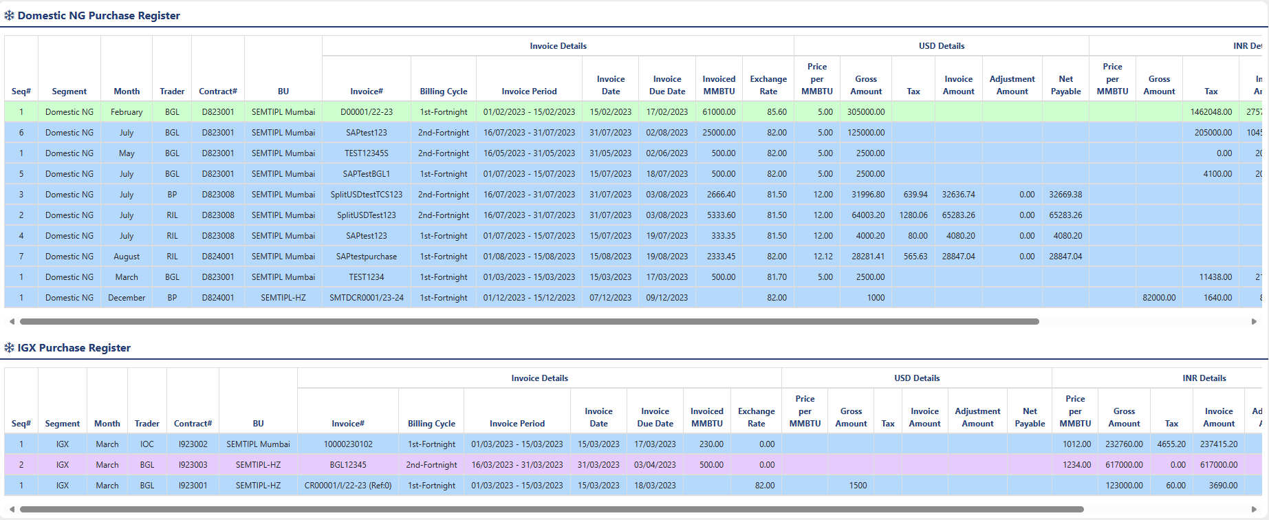

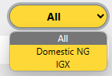
User can filter Data according to the Contract type by using dropdown located at the top right corner.

Data in the reports are highlighted with different colors. The meaning of all colors shown in below image.

Auditing

The "Audit Trail" within the "Admin" module comprehensively tracks and stores all user actions performed across the various sub-menus of the "Purchase" module, providing a detailed record of changes made to the system's master data.

